The Root Cause Analysis tool may be used at the beginning of the root cause analysis process during Step 2 of CIM. This worksheet is designed to support teams in brainstorming a list of potential symptoms and root causes for an identified problem area. It supports analysis of the problem and helps teams develop a shared understanding of the problem. This tool may be used in isolation or as part of a deeper root cause analysis investigation.

Participants
Roles: Facilitator, timekeeper, and notetaker (optional)
Group Size: 3-5 people
Time: 20-30 minutes

Materials
In Person:
- Shared notetaking: large poster paper, markers, and sticky notes
- Individual notetaking: sticky notes or paper and pen or pencils.

Virtual: Slide deck to share on-screen, Jamboard, Google or Teams shared docs.

Instructions for Use
1. Write the problem area on a shared space for everyone to see.

2. Brainstorm problem symptoms and suspected causes on their copy of the tree. Symptoms are observable indications that the problem exists. Causes are the suspected reasons for the problem and its observable symptoms.

3. Share out trees. Note similarities and key differences.

4. Create one shared tree that reflects group consensus.

5. Develop an action plan to investigate these suspected causes.

6. (Optional) Update your tree as you refine your understanding of the problem.
Note: This practice gets our mental models on the table. It does not mean we now know the root cause, but it does direct our attention towards what to investigate so that we can validate/invalidate the suspected causes with data during the root cause analysis process.

Brainstorming Space
Problem Area:
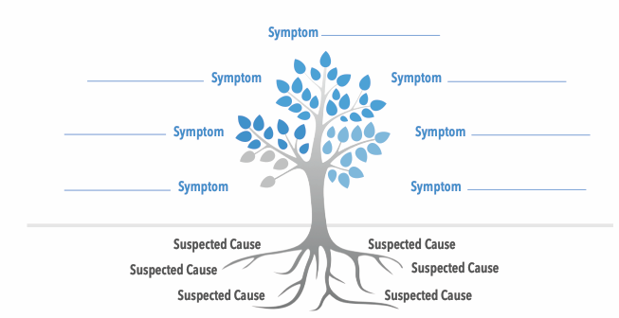

Key Takeaways | Lingering Questions
 | 1.
2.. | 2..
3. | 3.

Action Plan
Next Steps to Investigate Suspected Causes
1.
2..
3.

Adapted from a resource created by the System Improvement Leads (SIL): systemimprovement.org

