The historical data protocol may be used to support the data drilldown activity in Step 1 of the CIM Process.
This protocol is designed to be used in conjunction with the System Improvement Leads (SIL) Data Tools Dashboard and allows teams to document key trends and patterns in their State Performance Plan Indicator data over time.

Participants
Roles: Facilitator and Notetaker
Group Size: 3-7 people
Time: 1-2 hours

Materials
In Person, time 1-2 hours: Pen and/or pencils, highlighters. Additional copies of table form this protocol. Post-it notes.
Virtual: Shared virtual workspace.

Instructions for Use
1. Navigate to the Improvement Data Center:
https://systemimprovement.org/
a) Scroll down to “Improvement Data Center” and click “Discover.”
b) Select “Data Tools” and follow the prompt to log in either with Outlook or Google.
c) Click “Data Tools.”

d) Navigate to your targeted data set by selecting preferred Reporting Level (i.e., SELPA, geo-lead, district, etc.) and Organization.

2. For each indicator, use the included form to complete the following steps:
a) Private think time: 1-2 minutes to review the indicator data individually. Note on the included form if performance trends appear to be:
1. Stable
2. Inconsistent
3. Improving
4. Declining.
Utilize the “Trends and Observations” box to note if the target was met or not met, any outliers, and/or other observations.
b) Group go-rounds: Facilitator asks participants to share their categorization and any additional observations they noted.
Notetaker records all responses

3. Closing:
As a group, discuss the prompts in the summary table. Notetaker records group consensus.
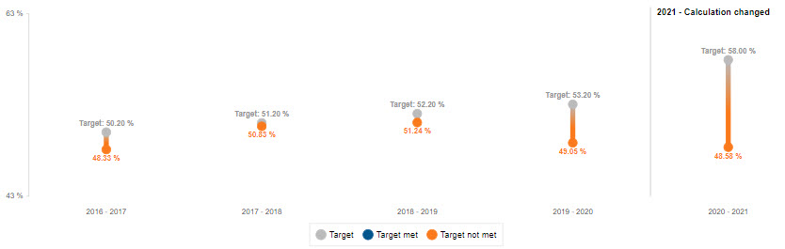

Indicators | 1 | 2 | 3 | 4 | Trends and Observations
Example |  |  |  |  | Performance was stable for the first 5 years (10-20% below target). Last year, performance increased and exceeded the target by 5%
1 – Graduation Rate
2 – Dropout Rate
*Decline in data shows progress.
3B – Statewide Assessment Participation
3C – Statewide Assessment Proficiency
4a – Discipline Rate Overall
4b – Discipline Rate by Ethnicity
5A – In Regular Classroom > 80%
5B – In Regular Classroom < 40%
5C – In Separate School
6A – Preschool LRE In Regular Program
6B – Preschool LRE In Separate Program
7A – Preschool Outcomes Soc/Emo Skills
- Increased
7A – Preschool Outcomes Soc/Emo Skills – Age Expectations
7B – Preschool Outcomes Knowledge and Skills - Increased
7B – Preschool Outcomes Knowledge and Skills – Age Expectations
Indicators | 1 | 2 | 3 | 4 | Trends and Observations
7C – Preschool Outcomes Appropriate Behaviors - Increased
7C – Preschool Outcomes Appropriate Behaviors – Age Expectations
8 – Parent Involvement
9 – Disproportionate Representation
10 – Disproportionate Representation by Disability
11 – Timely Eligibility Evaluation
12 – Timely Part C to B Transition
13 – Post-Secondary Transition Goals and Services
14A – Post-Secondary Outcomes Higher Ed
14B – Post-Secondary Outcomes Higher Ed + Employment
14C – Any Post-Secondary Outcomes Ed + Employment
Summary Categories
Enter indicators into the appropriate summary boxes | Missed target 3+ years | Stable 3+ years and met target | Inconsistent  *Recent significant change
Additional Notes
*Wonderings and Questions
Adapted from a resource created by the System Improvement Leads (SIL): systemimprovement.org

