A Fishbone diagram, also called a Cause-and-Effect diagram can help in brainstorming to identify possible causes of a problem and in sorting ideas into useful categories. A fishbone diagram is a visual way to look at cause and effect and helps teams focus on causes rather than symptoms.

Participants
Roles: Facilitator, Notetaker, Timekeeper
Group Size: 3-7 people
Time: 20-40 minutes

Materials
In Person:
- Shared notetaking: poster paper (posted prior to engaging in the protocol) and markers
- Individual notetaking: notebooks and post-its

Virtual: Jamboard, virtual slide decks, or another shared brainstorm space and space to diagram the Fishbone.

Instructions for Use
1. Define the problem. First, draw or place the fishbone diagram on poster paper or electronically for the group to see. As a team, identify the problem to be addressed. Document it on the head of the fish on the right-hand side of the diagram.
2. Brainstorm the causes of the problem. Ask: “Why does this happen?” Invite participants to independently write down potential causes. Then, direct participants to transfer causes to post-its, with one cause per post-it.
3. Group like causes. Invite participants to share one cause at a time and hand the cause to the recorder to begin organizing in like categories. Continue until all causes have been shared. During this process, engage participants by asking for feedback on groupings.
4. Label cause categories. Invite participants to propose category titles. Elicit feedback to identify if participants believe all causes are in the most accurate categories.
Note: There may be causes that are outliers. Place those on a “parking lot” to the side.
5. Reflect. Ask: “Do these causes reflect our initial hunches around why this problem is happening?” Make any additional changes. Finalize categories. This may include grouping categories or creating subcategories.
6. Close and identify next steps. Invite participants to reflect on their original brainstorm and the completed Fishbone, consider how thinking about the problem has evolved.
a) If the ideas need to be transferred to the fishbone document included, identify who will complete that.

Category | Category | Category
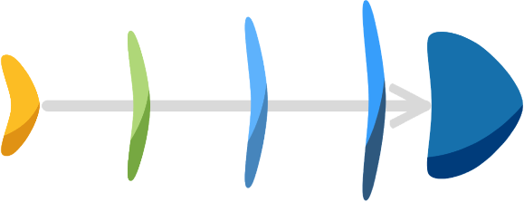
Category | Category | Category

Adapted from a resource created by the System Improvement Leads (SIL): systemimprovement.org

